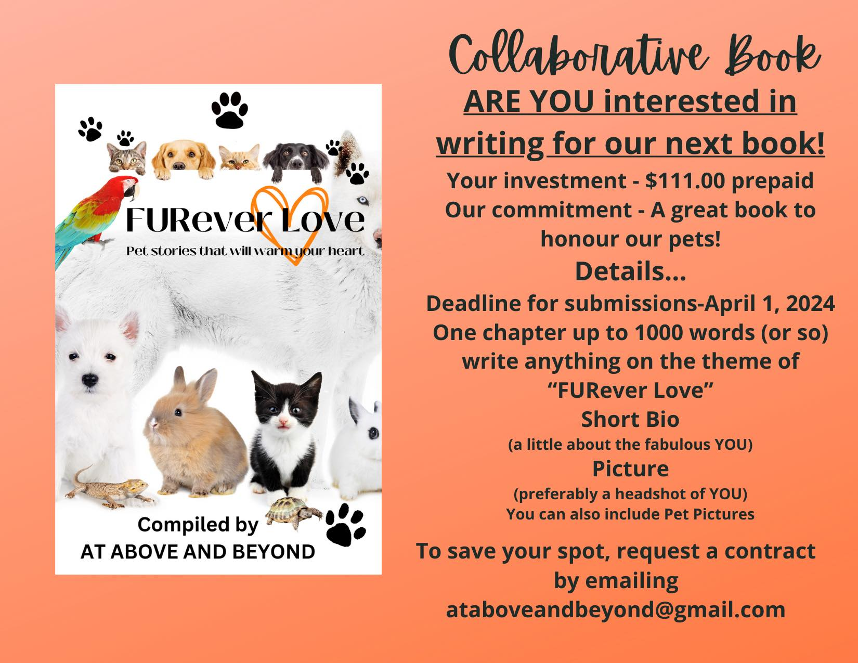

COLLABORATIVE AUTHOR PUBLISHING AGREEMENT

This Collaborative Author Publishing Agreement (the "Agreement") is entered into on this (NUMBER OF DAY) day of (MONTH), 2024, (the "Effective Date") between the following parties:

Author:
[Full Legal Name]
[Address]
[Email Address]
[Phone Number]

And the Publisher:
At Above And Beyond(AAAB)
Business Identification Number: 310600655
ataboveandbeyond@gmail.com

1. MANUSCRIPT DELIVERY:
The Author shall submit a new and original manuscript (the "Work") to the Publisher for inclusion in a collaborative book tentatively titled “FURever Love: Pet Stories That Will Warm Your Heart” The Work will be emailed in its entirety to ataboveandbeyond@gmail.com. The Work, a work of fiction/nonfiction, shall consist of approximately 1000 words including photographs/illustrations and is due by April 1, 2024. The theme of the Work shall revolve around Pets. The Author affirms that the Work is an original creation and does not incorporate artificial intelligence (AI).

2. PERMISSION:
The Author hereby grants full permission for the use of their headshot photo, bio, and submission in the collaborative book. This grant extends to non-exclusive global rights in all languages, for use by AAAB in the book titled "FURever Love: Pet Stories That Will Warm Your Heart”(title may be subject to change) and its subsidiary uses, promotional activities, future revisions, and editions at the Publisher's discretion.

3. COMPENSATION:
The Author acknowledges that in place of offering profit share (royalties), AAAB will make a charity donation to an organization of its choosing.

4. COPYRIGHT AND OWNERSHIP:
The Author retains ownership of their manuscript and retains the right to reproduce it even after the book is published.

5. EDITING:
AAAB has the right to edit the Work for grammar, punctuation, and formatting purposes. AAAB will have final say in all edits and formatting choices.

6. MARKETING:
The Author agrees to actively participate, at no cost, in the marketing of the book, utilizing any provided marketing materials by AAAB. AAAB will make reasonable efforts to market the Work through various channels.

7. COMMUNICATION:
All communications with AAAB shall be conducted through email (ataboveandbeyond@gmail.com). Facebook Messenger may not be used for communication.

8. TERMINATION:
Either party may terminate this Agreement by providing written notice if the other party breaches a material term of the Agreement. Upon termination, all work by AAAB will stop and any fees paid will be non-refundable to the Author.

9. GOVERNING LAW:
This Agreement shall be governed by and construed in accordance with the laws of the province of Ontario, Canada. Any disputes will be heard in the Niagara Region of Canada.

10. PAYMENT TERMS
SERVICE FEES:
The Author agrees to pay $111 CAD+SERVICE FEES if applicable] to AAAB for the services rendered under this Agreement. This amount covers the costs associated with participation in the collaborative book.
PAYMENT METHOD:
Payment shall be made via electronic transfer (eTransfer) or PayPal to the following account: Email Address: ataboveandbeyond@gmail.com
NON-REFUNDABLE PAYMENT:
The Author acknowledges and agrees that the payment made to AAAB for the services rendered is non-refundable. Once payment is made, there will be no refunds, exchanges, or credits, unless explicitly stated otherwise in writing by AAAB.
RECEIPT OF PAYMENT:
AAAB will issue a receipt to the Author upon the successful receipt and processing of the payment. The receipt will detail the services covered by the payment.
By making the payment, the Author acknowledges that they have read, understood, and agreed to the payment terms outlined in this section of the Agreement.

11. ENTIRE AGREEMENT:
This Agreement constitutes the entire understanding between the Co-Authors and the Publisher and supersedes all prior negotiations, understandings, or agreements, whether oral or written.
IN WITNESS WHEREOF, the Parties hereto have executed this Solo Author Publishing Agreement as of the Effective Date.

ELECTRONIC SIGNATURE DECLARATION
I, [Your Full Legal Name], hereby declare that my electronic signature affixed to the AAAB Solo Author Agreement (the "Agreement") dated [Effective Date], serves as my genuine and binding expression of intent to be legally bound by the terms and conditions outlined in the aforementioned Agreement.
I understand that my electronic signature, which may consist of my typed name, electronic mark, or other unique identifier, is legally equivalent to my handwritten signature. IN WITNESS WHEREOF, I have electronically signed this declaration on [Date].

[Printed Full Legal Name]
[Address]
[Phone Number]
[Email Address]

At Above And Beyond
ataboveandbeyond@gmail.com
Business Identification Number: 310600655

